1. Symptoms
- OPC data is not communicating or receiving with My Application Software.
- My Application Software (customize software) operating normal with other applications, and no abnormal symptoms has been seen till now with any other software or system.
- If we exit from and run the My Application Software again then we receive the OPC data’s properly.
- We confirm that, in program, OPC data is lost when Error is identified in Event Log
- Please check the below window event viewer captured error.

2. Window Event Viewer, Captured Event Logs
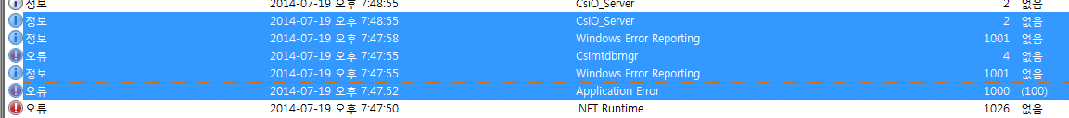
1) Application Error
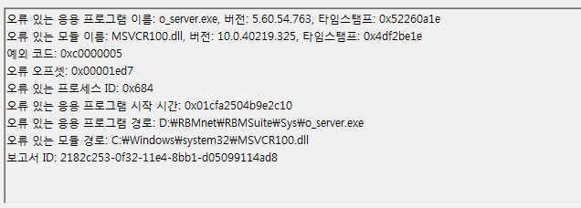
* English Translation in Detail
Faulting Application Name: o_server.exe, Verson: 5.60.54.763, Timestamp: 0x52260a1e
Faulting Module Name: MSVCR100.dll, 버전: 10.0.40219.325, Timestamp: 0x4df2be1e
Exception Code: 0xc0000005
Fault Offset: 0x00001ed7
Faulting Process ID: 0x684
Faulting Application Start time: 0x01cfa2504b9e2c10
Faulting Application Path: D:\RBMnet\RBMSuite\Sys\o_server.exe
Faulting Module Path: C:\Windows\system32\MSVCR100.dll
Report ID: 2182c253-0f32-11e4-8bb1-d05099114ad8

2) Windows Error Reporting
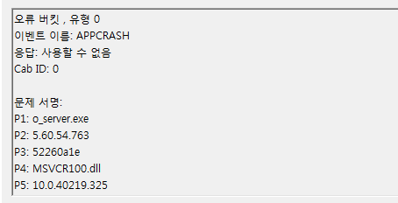
* English Translation in Detail
Fault bucket , type 0
Event Name: APPCRASH
Response: Not available
Cab ID: 0

Problem signature:
P1: o_server.exe
P2: 5.60.54.763
P3: 52260a1e
P4: MSVCR100.dll
P5: 10.0.40219.325
P6: 4df2be1e
P7: c0000005
P8: 00001ed7
P9:
P10:

Attached Files:
C:\Users\CSISERVERS\AppData\Local\Temp\WEREFDA.tmp.appcompat.txt
C:\Users\CSISERVERS\AppData\Local\Temp\WERF2D7.tmp.WERInternalMetadata.xml
C:\Users\CSISERVERS\AppData\Local\Temp\WERF2D8.tmp.hdmp
C:\Users\CSISERVERS\AppData\Local\Temp\WERFCA9.tmp.mdmp

This file is available at.
C:\ProgramData\Microsoft\Windows\WER\ReportQueue\AppCrash_o_server.exe_ceda1d4b76c61a568b1432d47305c951e206b45_cab_15affd13

Anaylsis Symbol:
Rechecking for solution: 0
Report ID: 2182c253-0f32-11e4-8bb1-d05099114ad8
Report Status: 4

3) Csimtdbmgr
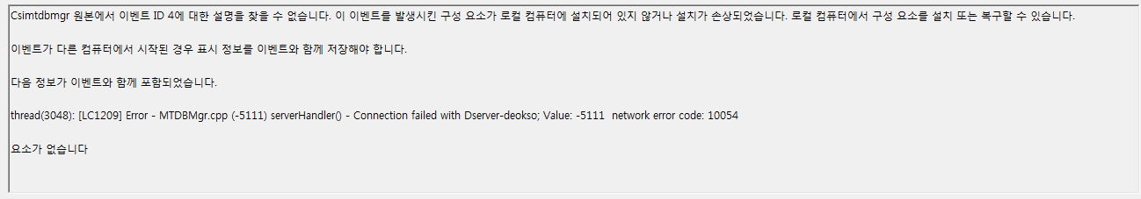
* English Translation in Detail
The description for Event ID 2 from source Csimtdbmgr cannot be found. Either the component that raises this event is not installed on your local computer or the installation is corrupted. You can install or repair the component on the local computer.

If the event originated on another computer, the display information had to be saved with the event
The following information was included with the event:

thread(3048): [LC1209] Error - MTDBMgr.cpp (-5111) serverHandler() - Connection failed with Dserver-deokso; Value: -5111 network error code: 10054

요소가 없습니다

4) Windows Error Reporting
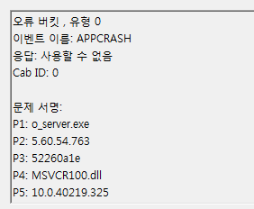
* English Translation in Detail
Fault bucket , type 0
Event Name: APPCRASH
Response: Not available
Cab ID: 0

Problem signature:
P1: o_server.exe
P2: 5.60.54.763
P3: 52260a1e
P4: MSVCR100.dll
P5: 10.0.40219.325
P6: 4df2be1e
P7: c0000005
P8: 00001ed7
P9:
P10:

Attached files:
C:\Users\CSISERVERS\AppData\Local\Temp\WEREFDA.tmp.appcompat.txt
C:\Users\CSISERVERS\AppData\Local\Temp\WERF2D7.tmp.WERInternalMetadata.xml
C:\Users\CSISERVERS\AppData\Local\Temp\WERF2D8.tmp.hdmp
C:\Users\CSISERVERS\AppData\Local\Temp\WERFCA9.tmp.mdmp

These files may be available here.
C:\ProgramData\Microsoft\Windows\WER\ReportQueue\AppCrash_o_server.exe_ceda1d4b76c61a568b1432d47305c951e206b45_cab_15affd13

Analysis symbol:
Rechecking for solution: 0
Report ID: 2182c253-0f32-11e4-8bb1-d05099114ad8
Report Status: 0

5) “CsiO_Server”
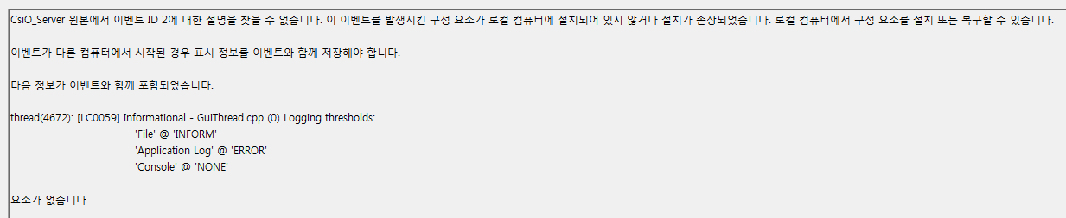
* English Translation in Detail
The description for Event ID 2 from source CsiO_Server cannot be found. Either the component that raises this event is not installed on your local computer or the installation is corrupted. You can install or repair the component on the local computer.

If the event originated on another computer, the display information had to be saved with the event
The following information was included with the event:

thread(4672): [LC0059] Informational - GuiThread.cpp (0) Logging thresholds:
'File' @ 'INFORM'
'Application Log' @ 'ERROR'
'Console' @ 'NONE'

요소가 없습니다

3. Recent Status
1) Confirmed that, event log is visible before the communication is broken.
2) When we exit from program (My Application Software) and re-start, then My Application Software is receiving the OPC data, it means that OPC and My Application Software is communicating between them well.
3) This error occurs when the connection between the OPC is not broken, and seems to have the restored together, My Application Software attempts to forcibly reconnect but no response.
To get response we must restart the program.
4) Window and program reinstalled, data request time is reconfigured (change the data requested time to longer) but the situation is same
5) Most of time it occur between 10 hours, but we confirmed that this occurs at approximate when it is more than 24 hours.

4. System Information
1) PC : I7 – 4770 CPU, 8GB Ram
2) OS : Windows 7 Professional 64Bit (Korea)
3) MHM version : 5.60
4) CSI 6500 Firmware Version : 3.20d
5) Application Program Tool : LabVIEW 2013

