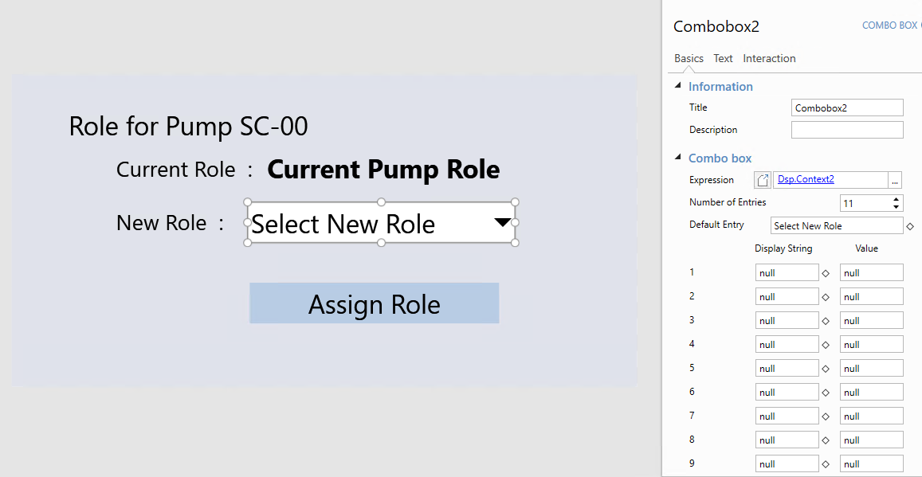
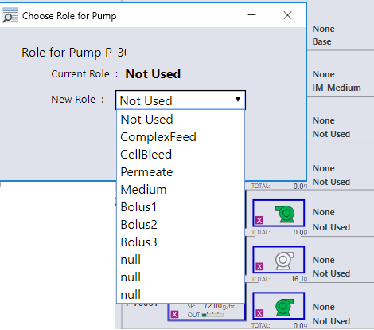
The Combobox options named as NULL are used options, hence it will not allow to choose.
If required, we may change that text to BLANK instead of NULL but the number of entries will remain same (can’t make dynamic)
