Please find the follow up of our response to your questions below relating of 2440FV-112 failure.

 •            What’s happen after 300s if a communication lost to the positioner?

    The valve will close by follow for FSTATE_VAL =0% as setting of AO block.

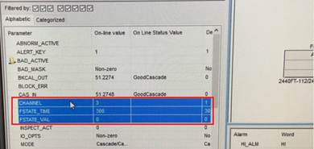

From the point of review, we did not find any signals from the H1 Card fieldbus by Hardware error/Communication failure . These segments consisted of these tags.

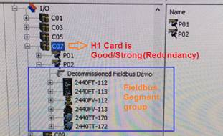

Segment design :

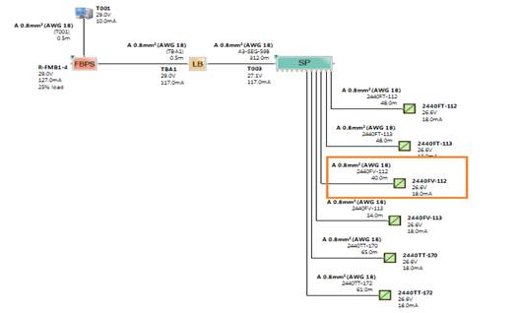

When we went to the Filters Alarm of each module in the segment on Delta V DCS , there was only Tag 2440FV-112 with alarm the communication failure at **10:50:24 AM on 8 Dec, 17** as shown below picture, where the other device is still normal (Good Service).

  Actual activities for system/device diagnostic

- No hardware H1 Card of  fieldbus failure.

- No Accident removed of Terminals

- No Loss of input signal to the valve (ie AI function block)

- No Loss data by segment  macrocycle calculation out of limited (Requested Time : 250ms and Actual Time : 165ms) **is good**

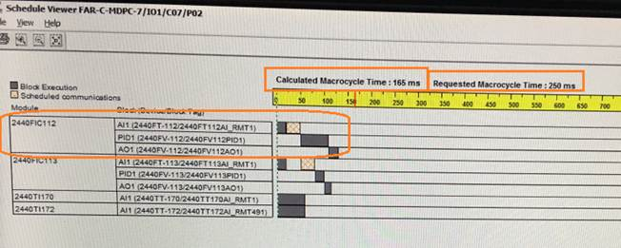

* 2440FV-112 alarm module (Positioner Device)

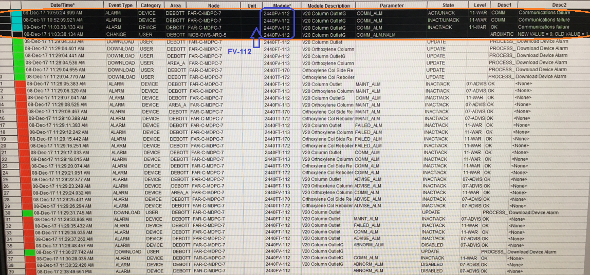

Then we open Block error properties for AO block show : **Out of Service (OOS) only 1 selected value for AO positioner**.

According to Samson investigation report number , They have block error by the Out of service also.

1.VIEW4_3731_5_2123860_2017-Dec-08 2440-FV-112 (PTTGC5) out of servic ...

**Section** 7.1.2. Block errors  ,7.1.2.2. Positioner (AO, TRD) and 7.1.2.3 Process controller (PID) with we assigned to control in the field (PID and AO block located in valve positioner)

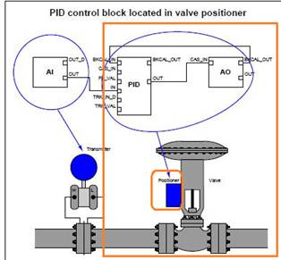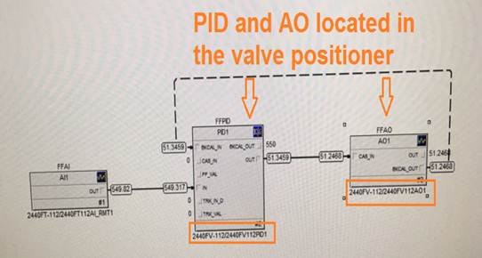

7.1.2. Block errors

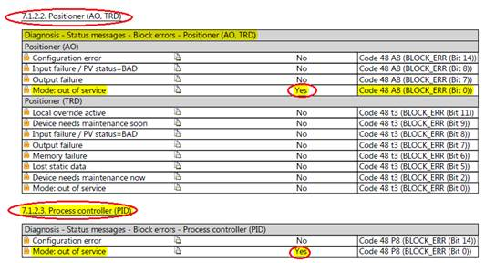

Normally, FSTATE_TIME and FSTATE_VAL are setting for AO Block  of all control valve module in ARO 2 plant .But we never saw AO block mode executed  to Out of Service.

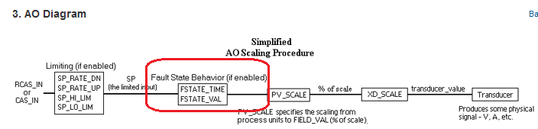

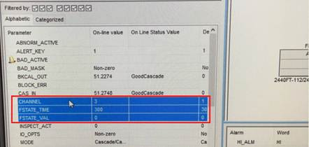

•            Switch the positioner to operating mode LO (as you can see on the next screen shoot) and is the valve position 0%?

    I didn't know what is the matter but I understood If the device is locally set to the MAN mode, the AO Transducer Block is set to LO. DCS never change/write mode during on normal operation. (No permissive work by senior operator / Shift supervisor and Shift manager approval) It might happen after who go the diagnostic test to check for common error or not because of the incident on that day, we just only  have a Commissioning / Decommissioning to change the new valve positioner on DCS Delta V exploring with download after they have requested to replace the new device ( positioner) from Field Maintenance team in the afternoon of that day.

* Static Revision Counter

Static Revision Counter ( Counters from 14 --->16)

: This is possible when they changed the parameter in the resource block during a device change. (Use spare from 2100FV-1) The difference parameter setting See Audit trail show the event type by configuration change during positioner replacement .

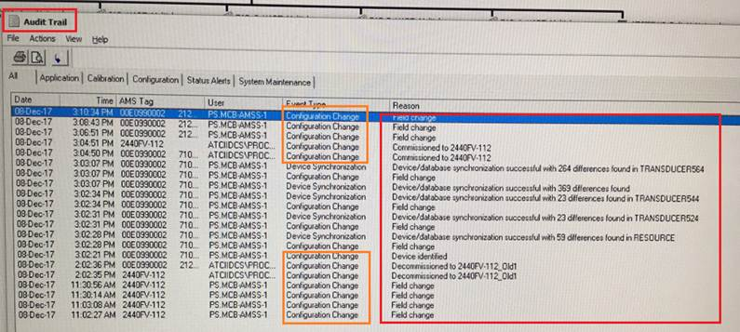

   Did you observe **for Classification report error**?

From the picture below, you will see the message ( ie Maintenance required, Device need Maintenance soon.)

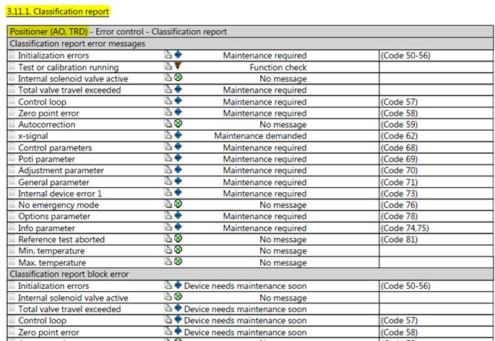

**What is a recommendation?  Do we need to reset / restart the processor of positioner ?**

